Dated 20.03.2024

Rahul Wagh yotube Channel Link

<https://www.youtube.com/watch?v=ydxEeVAqVdo&t=25s>

**Mastering AWS: NAT Gateway Setup in Your VPC - A Step-by-Step Tutorial**

Create VPC in N.Verginia ( 1st Region )

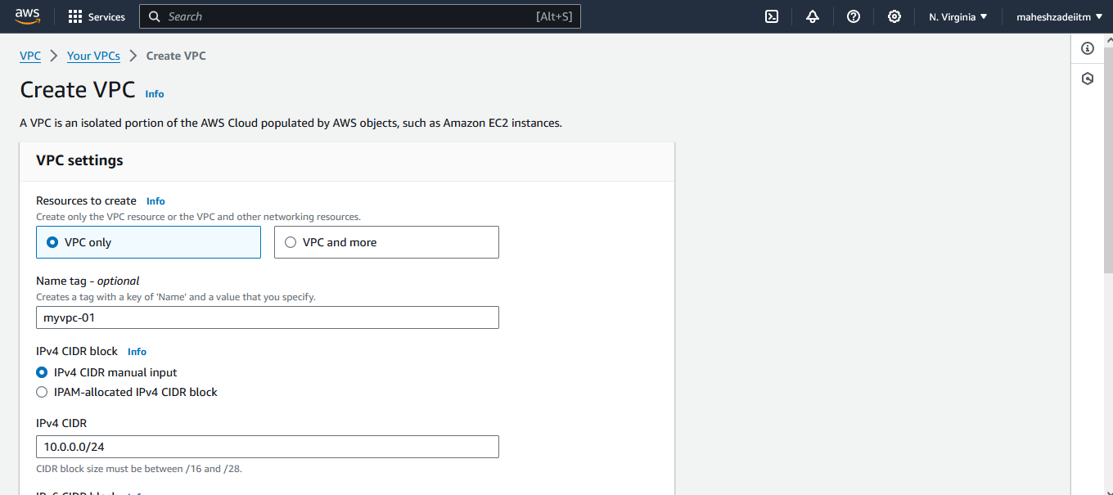

Create VPC in Ohio ( 2nd Region )

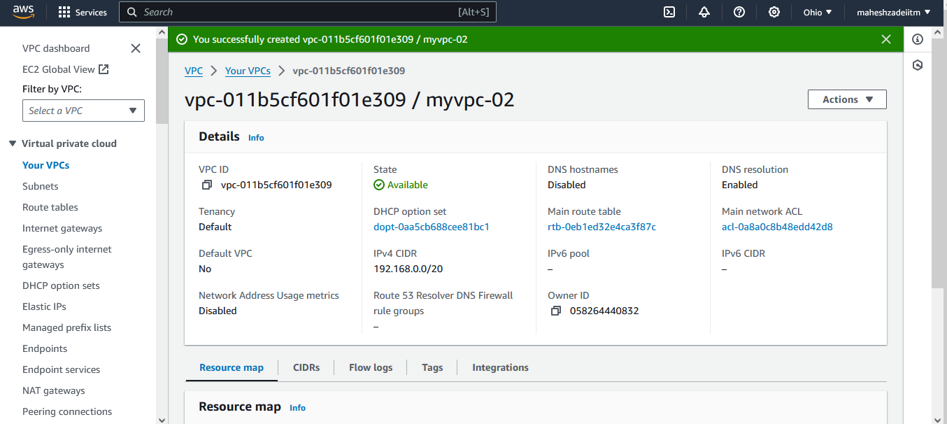

Create VPC in Ni California ( 3rd Region )

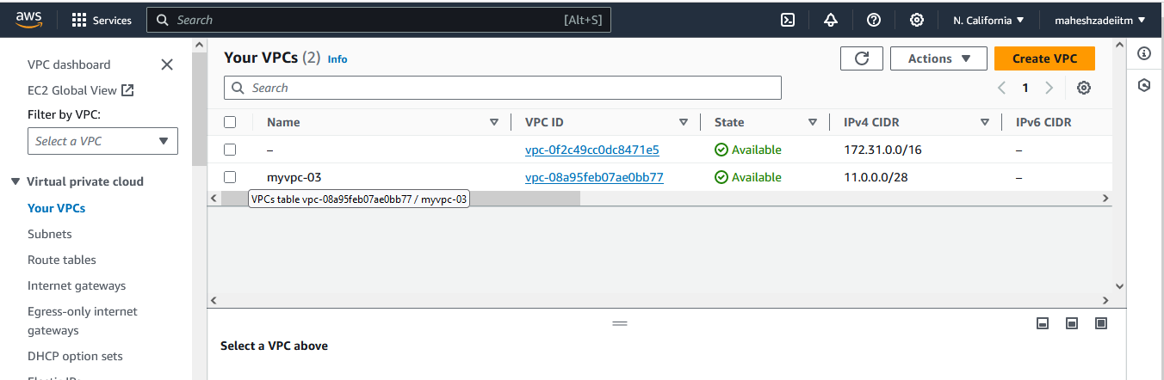

what is created along with VPC ??

Is there any default Subcomponents are created automatically?

4 Subcomponents created

1 - DHCP Option set

2 - Main RT

3 - Main network ACL

4 - Default Security Group

what next?

Subnet

Route Table

Internet Gateway

NAT Gateway

256

equal or unequal

Jump (Non-Critical) Servers

Application servers

DB Servers

Gateway Servers

Frontend Servers

Backend Servers

etc

10 - IPs

1 to 5 IPs >>>> Jump servers >>>> AZ -1

6 - 10 IPs >>>> Application Servers >>>> AZ-2

1 IP reserved for broadcasting and 1 IP reserved for loopback

256

Registering your VPC along with your other resources on top of AZ

1 - Uniform

2 - HA

3 - Registering on AZ

sub + net >>> subnet

256 >>>

256/4 >>>> 64

Create a Subnet

Open >>> https://www.davidc.net/sites/default/subnets/subnets.html

Make your CIDR into 4 equal blocks

Go to the Subnet and create a Subnet

Give the subnet name along with AZ code

Give the first CIDR and Add Subnet

Repeat for the second & Third Subnets But leave 4th one for future purpose.

What we learnt ????

1 - how to create a Traditional VPC with Subnet

2 - How to delete the subnets and troubleshoot the subnet >>>> as long as there is no resources are placed on Subnet you are allowed to delete them, once any resource is on Subnet you can't delete it, this you can test as well.

3 - Not mandatory to use and create all the subnets in advance, you can keep them open for future.

Can I launch any future resources on VPC where it doesnt have any single Subnet?

NO

******** IMP

Can I create my one Subnet on top of TWO AZ >>>>> NO

Can I use one AZ to create my TWO Subnets >>>>>>> YES

Q1 >>>> Where can I see my 256 IPs? or where can I see my 64 IPs at least??? NO

But you can see (your subnet range - 5 == ??? )

64 -5 = "59"

From every subnet range >>> First 4 IPs and last 1 IP will be reserved by AZ for the below purpose

1st IP : Network address.

2nd IP: Reserved by AWS for the "VPC router".

3rd IP : Reserved by AWS. The IP address of the "DNS" server is the base of the VPC network range plus two. For VPCs with multiple CIDR blocks, the IP address of the DNS server is located in the primary CIDR. We also reserve the base of each subnet range plus two for all CIDR blocks in the VPC. For more information, see Amazon DNS server.

4th IP: Reserved by AWS for "future" use.

5th IP : "Network broadcast" address. We do not support broadcast in a VPC, therefore we reserve this address.

what you have done so far ?

Launched VPC && Subnet on top of that.

Technical workshop ???

1 - when there is any resource can I delete the VPC ? NO

2 - When there is no Subnet can I launch any resource? NO

Public RT >>>>> Main RT >>>>> Renamed

Private RT >>>>> Created

VPC >>> DONE

Subnet >>> DONE

RT >>> DONE

Q1 - Just changing the name as public or private >>> they will really act as a Public (or) Private

NO

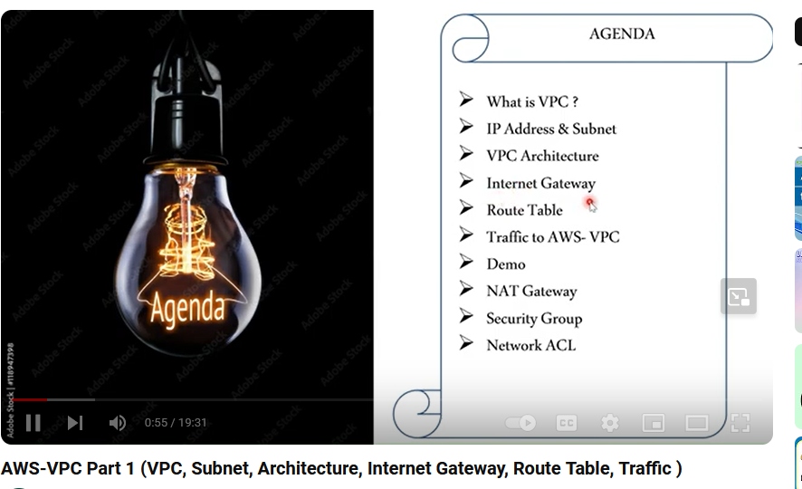

https://www.youtube.com/watch?v=ydxEeVAqVdo&t=25s